June 26, 2023

First time right: Titanium machining at AMAG components

It is not uncommon for passenger aircraft in the Airbus A320 family, business jets, helicopters, transport aircraft, and freight aircraft to have complex components and assemblies from AMAG components on board. The titanium components, which are often critical to safety, are manufactured on a "first time right" basis on various machines at the sites in Karlsruhe and Übersee on Lake Chiemsee, Germany – including on CHIRON Group machining centers. The company uses two machines of the MILL Series and one FZ 16 S five axis, and in April 2023 also brought in two DZ 22 W five axis machines for double-spindle machining of large components in short cycle times.

AMAG components is a specialist in the manufacture of ready-to-install metallic components and assemblies for the international aerospace industry. Its Karlsruhe site has been producing aerospace components since as far back as 1962, and in 1970, the company supplied titanium forged parts for the first Airbus A300 aircraft. Since then, AMAG components – today part of AMAG Austria Metall AG, headquartered in Ranshofen – has continuously expanded its expertise in machining complex materials.

The focus of production is on aluminum structural components and highly-stressed titanium components for international aircraft manufacturers. The component assembly plants in Karlsruhe and Übersee have Nadcap certification for Aero Structure Assembly (ASA), one of the most complex accreditations for processes in the aerospace industry.

High-quality machine fleet
The road to a safe, seamlessly documented process starts with the selection of machining centers. These need to produce components on a "first time right" basis: The very first part must meet quality requirements 100% – even with long machining times. The machine fleet at AMAG components is extremely high quality for this reason. Since 2013, the machine fleet in Karlsruhe has included MILL Series machining centers from the CHIRON Group for manufacturing medium-sized aluminum structural components: It contains one MILL 3000 and one MILL 4500, both with a divisible working area for parallel machining as well as loading and unloading.

FZ 16 S five axis for AMAG components with HSK-A100
The CHIRON Group was also one of the candidates in the selection process for a new titanium machining center in 2018. The concept of the FZ 16 S five axis, which was installed later that year, "was a good fit for the requirements," explains Markus Löhe, Key Account Manager for Aerospace. "Our new machining center also won the company over when it came to precision and highly dynamic and static rigidity. However, when we launched the FZ 16 S five axis, we had only designed it with an HSK-A63 interface – but the titanium components at AMAG required a higher torque, and a bigger interface also made more sense in light of the projected machining rates."

So the CHIRON Group fitted the machining center for AMAG components with an HSK-A100 interface and a spindle with torque of 400 Nm. The commissioning in April 2020 marked the start of a test phase – which was planned for twelve months, but was extended to two years due to COVID-19. The Engineering departments had regular meetings during that period. According to Andreas Pitz, Technical Consultant at the CHIRON Group, the live operation showed "that the larger interface when machining high-strength materials with long tools delivered the desired result: Dimensional stability from the very first part."

As a result, the FZ 16 S five axis met the workpiece quality requirements and since the end of the test phase has been machining both forged titanium components and titanium plate parts, including elements for aircraft doors and wing to body parts. These are largely components that are critical to safety and that require First Part Qualification (FPQ). This includes checking the impact of the machining process on the material's microstructure quality – the machining center scored highly in this regard too.

Two additional machining centers for Übersee
Since then, the Übersee site on Lake Chiemsee has also started using machining centers from the CHIRON Group – two DZ 22 W five axis units. When the 22 Series was launched in 2020, the plus points of the 16 Series – high precision, dynamics and outstanding surface quality – were transferred to large workpiece machining. Before the investment, test machining was undertaken in Tuttlingen, Germany for stainless steel and titanium components. A key criterion for AMAG components was that productivity was to be improved through the new machines – with double spindles and a tool changer. The new machining centers achieve much more stable results across a series than those used in the past for these components, exceeding the customer's expectations. To reach this level as quickly as possible, Torsten Schmid provided second-level support as the permanent contact person for CHIRON Group Service during the start-up phase.

SmartLine digital systems
Two digital systems from the SmartLine portfolio are also used on the DZ 22 S five axis: DataLine collects machine and process data live, and the production process can be continuously optimized on a targeted basis using the diagnoses. Through RemoteLine, a CHIRON Group Service expert receives a notification and, after authorization, gains access to the machining center; they can help with operating issues and carry out remote diagnosis and maintenance if incidents arise. This prevents downtime, increasing the availability of both double-spindle machines at AMAG components in Übersee.

Key Account Manager Markus Löhe and Technical Consultant Andreas Pitz are currently supporting the overseas team in designing a complementary system that will automatically feed both machining centers with workpieces.

Insert 1
Efficiency and precision for aerospace

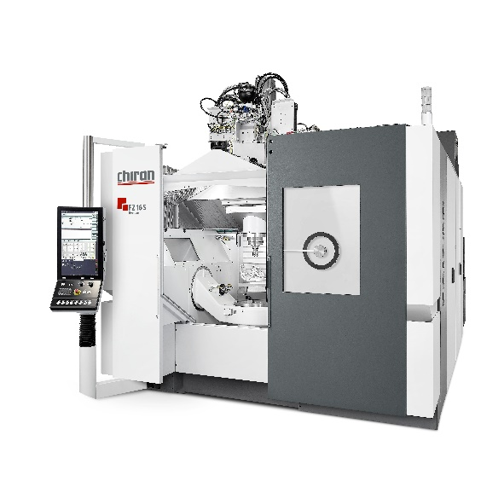
FZ 16 S five axis
With a powerful main spindle offering torque of 400 Nm and an HSK-A100 interface, the FZ 16 S five axis is designed for machining complex structural components from a solid block. The mobile gantry design ensures excellent static and dynamic rigidity, while powerful drives provide the required dynamics. The FZ 16 S five axis with HSK-A100 is also impressive when it comes to precision thanks to the robust basic design and high thermal stability.

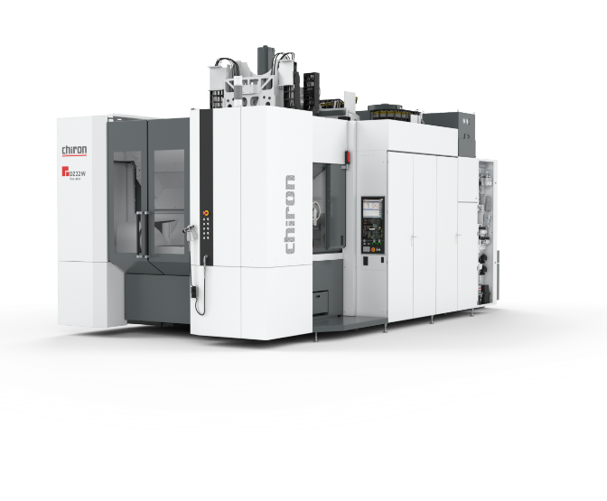
DZ 22 W five axis
The double-spindle machining center is based on the same machine platform as the 16 Series and, with a spindle distance of 600 mm and tool changing during regular machine operation, is particularly suitable for producing large, complex workpieces for the automotive and aerospace industries. The machining center can be expanded to a fully automated complete solution for increased utilization.

Insert 2:
From Heinkel-Werk to AMAG components at the Karlsruhe site
1954: Production of the Heinkel Tourist motor scooter
1962: Machining of structural components for the aerospace industry
1970: Machining of titanium forged parts for the first Airbus A300
2006: Takeover of the Karlsruhe site by Aircraft Philipp
2014: Strategic reorientation to the production of ready-to-install components
2020: AMAG Austria Metall AG takes over 70% of the German Aircraft Philipp Group (ACP) headquartered in Übersee on Lake Chiemsee.
2022: At the end of the year, AMAG becomes the sole owner and the company changes its name to AMAG components.

Further information

AMAG components
www.amag-al4u.com

CHIRON Group
www.chiron-group.com

About the CHIRON Group

The CHIRON Group, headquartered in Tuttlingen, Germany is a global company specializing in CNC vertical milling and mill-turn machining centers, as well as turnkey and automation solutions. Comprehensive services, digital solutions and products for additive manufacturing complete the portfolio. The Group has a global presence, with production and development sites, sales and service subsidiaries, and sales agencies worldwide. Around two thirds of machines and solutions that are sold are exported. Key customer sectors are the automotive, mechanical engineering, medicine and precision engineering, aerospace industries, as well as tool manufacturing.

Contact person for editors:

CHIRON Group SE
Christina Messmer
Kreuzstraße 75, 78532 Tuttlingen, Germany
Phone: +49 (0)7461 940-3712

Mail: christina.messmer@chiron-group.com
www.chiron-group.com

Image captions

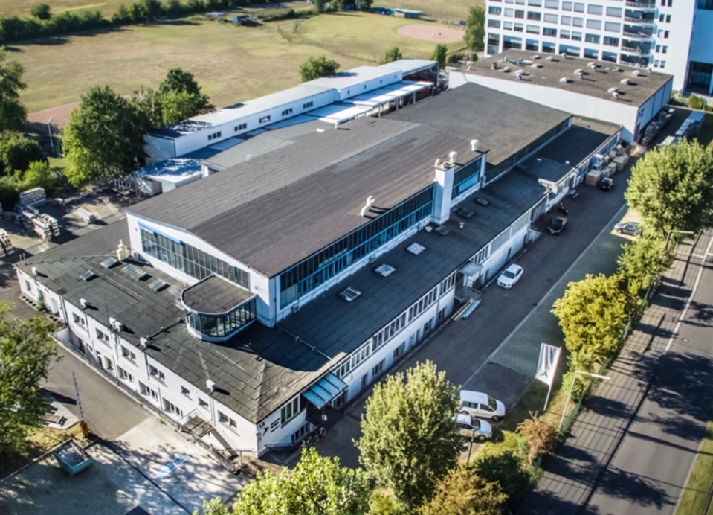

Picture 1: The AMAG components site in Karlsruhe
Source: AMAG components

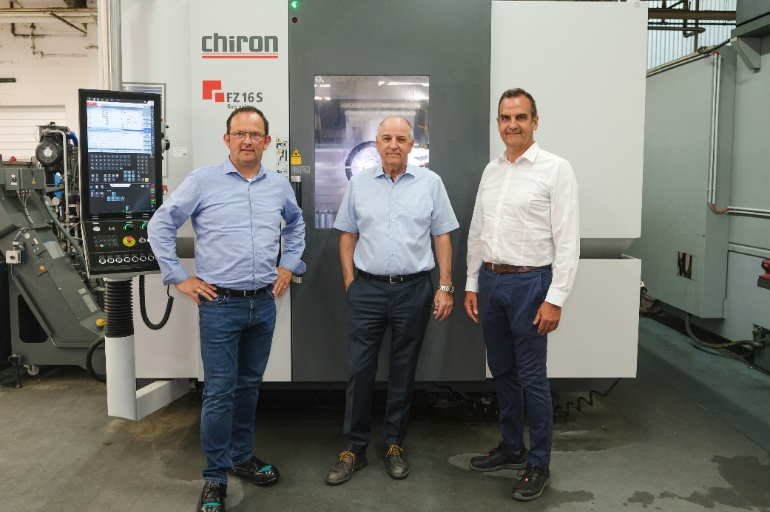

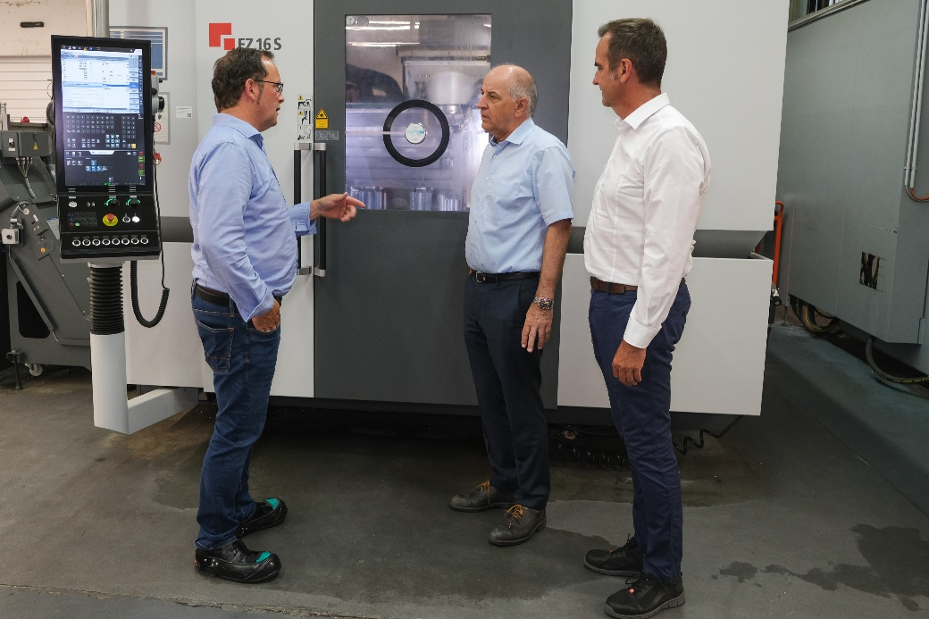

Picture 2+3: Collaborating professionally and personally to achieve project success (left to right): Markus Löhe, Key Account Manager Aerospace at the CHIRON Group, Timm Dinges, Managing Director of AMAG components in Karlsruhe, and Andreas Pitz, Technical Consultant at the CHIRON Group

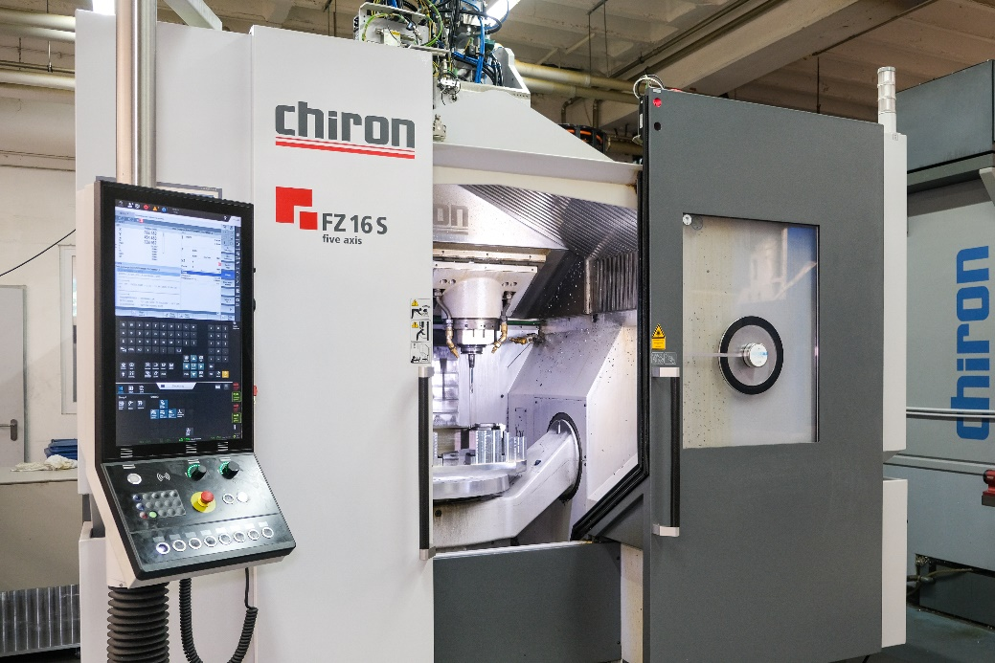

Picture 4: The concept of the FZ 16 S five axis meets the requirements of AMAG; the new machining center won the company over, particularly due to its precision and highly dynamic and static rigidity.

